 | Patient Tracker System  Technical Design Document  1.0
 | Prepared By / Last Updated By | Reviewed By | Reviewed By | Approved By
Name | Nikhil Omar | Kshitij Kumar | Harsh Pradhan | Prateek Kasera
Role | Team Member | Team Member | Team Member | Scrum Master
Signature | Nikhil Omar | Kshitij Kumar | Harsh Pradhan | Prateek Kasera
Date | 4/12/19 | 4/12/19 | 4/12/19 | 4/12/19

Table of Contents

1.0 Introduction 3
1.1 Purpose of this document 3
1.2 Scope 3
1.3 Intended Audience 3
1.4 Definition & Acronyms 3
2.0 Conventions and Standards Followed 5
3.0 Assumptions, Dependencies and Risks 5
3.1 Assumptions: 5
3.2 Dependencies: 5
4.0 Schematic Diagram 5
5.0 Use Case Realization 6
5.1.1 Admin Registration 6
a. Functional Requirement 7
b. UI Validations 7
c. UI Controls 8
d. UI Methods Definition 9
e. UI Design 11
6.0 Database Design 12
6.1 Data Model 12
The following is a schematic view of the database design 12
6.2 Tables Structure 12
7.0 Change Log 18

Introduction

Purpose of this document
The purpose of the detail design document is to define the detailed design for all the components of Patient Health Tracker system that are specified in the Business Requirement/Use case document. All the low level components, interfaces and integrations are detailed out in this document.

Scope
This sub-section shall state the scope of this detailed design document
• Create and maintain Admin information.
• Create and maintain patient information.
• Create and maintain Doctor information.
• Create and maintain Clerk information.
• Create and maintain Medicine information.
• Create and maintain Prescription information.
• Generate, maintain Bill information.

Intended Audience
The intended audience for this document are
- Developers, testers, other associates in the project
- Technical lead, Scrum Master
- Product Owner

Definition & Acronyms
Acronyms | Definitions
PTS | Patient Tracking System

Conventions and Standards Followed
The modules under scope needs to adhere to the coding standards and guidelines


Assumptions, Dependencies and Risks

Assumptions:
- Once the application is built the PATIENT TRACKING SYSTEM will manually load the Admin list into the system.
- There will be no concurrent Admins for the application. The Patient profile will be maintained by the Admin.

Dependencies:
- Availability of database design characteristics & access shall be defined by the
- Resource availability throughout each of the sprint

Schematic Diagram
A schematic, or schematic diagram, is a representation of the elements of a system using abstract, graphic symbols rather than realistic pictures. It gives an overview of overall system
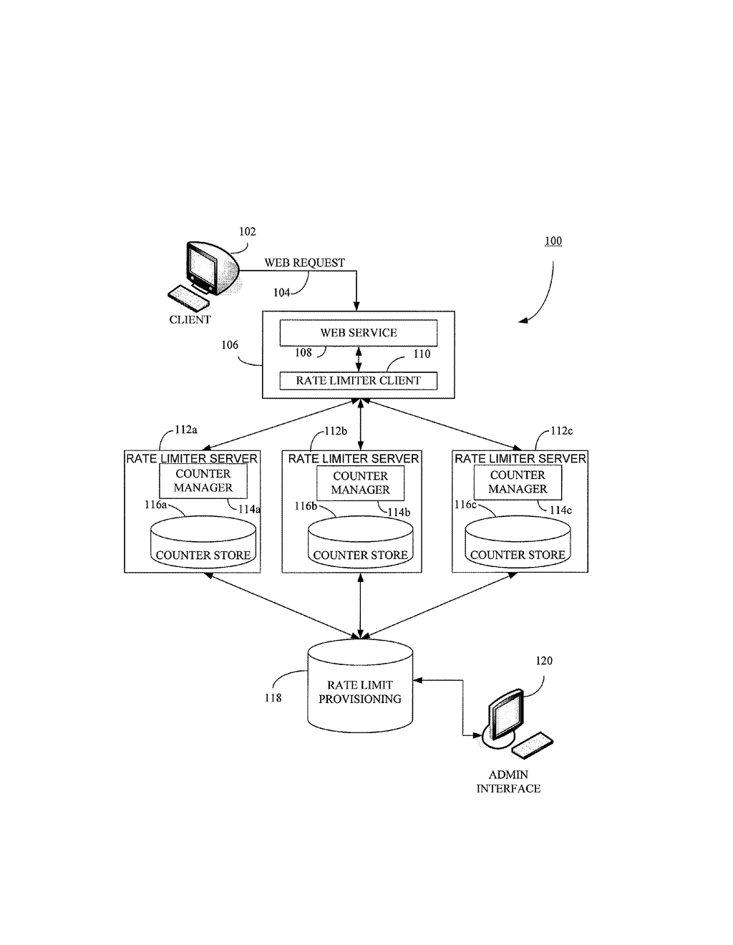
The above pic is only an example and not representational of the Patient Health project

Use Case Realization

Admin Registration

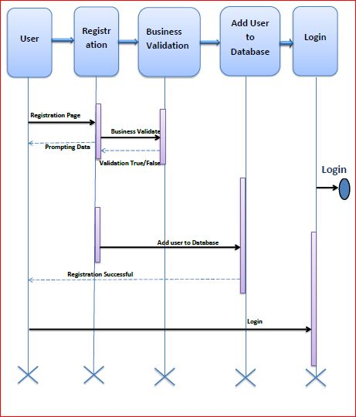

Functional Requirement
. Login Page checks the authentication of the Admin and based on his role, directs the Admin to the respective page. Admin will provide with Add and Update Patient, Doctor, Clerk, Medicine and Bill Record Details, Regulation and Search regulation pages.

UI Validations
- Admin Id and Password fields are mandatory.
- Invalid Admin Id and / or password should not allow the Admin to get into the system

UI Controls
# | UI Component | Type | Name | Details
1 | Admin Id | Label | label_For_Admin_Id
2 | Admin | Text field | Textfield_Admin | To enter Adminname
3 | password | Label | Label_for_password
4 | password | Text field | Textfield_password | To enter password

UI Methods Definition
Method Name | Parameter | Details
LoginButton_Click | object sender, EventArgs e | Allows the Admin to login into the portal and register the patient.
ResetButton_Click | object sender, EventArgs e | Clears the details entered by the Admin.
HomeButton_Click | object sender, EventArgs e | Loads the Homepage after registration is done successfully.
AddButton_Click | object sender, EventArgs e | Allows the Admin to insert the Admin personal details
ResetButton_Click | object sender, EventArgs e | Resets all fields given by Admin.
Page_Load | None | None
GenerateBill_Button_Click | object sender, EventArgs e | Allows the Admin to calculate the Bill of Patient by prescription
SaveButton_Click | object sender, EventArgs e | Allows the Admin to Save the generated bill and mark it as billed
AddMedicineButton_Click | object sender, EventArgs e | Allows the Admin to calculate the Blood Count Details of Patient
AddDoctorButton_Click | object sender, EventArgs e | To store the details of a new doctor
AddPatientButton_Click | object sender, EventArgs e | To store the details of a new patient
AddPrescription_Button_Click | object sender, EventArgs e | Stores all the details in the database

UI Design
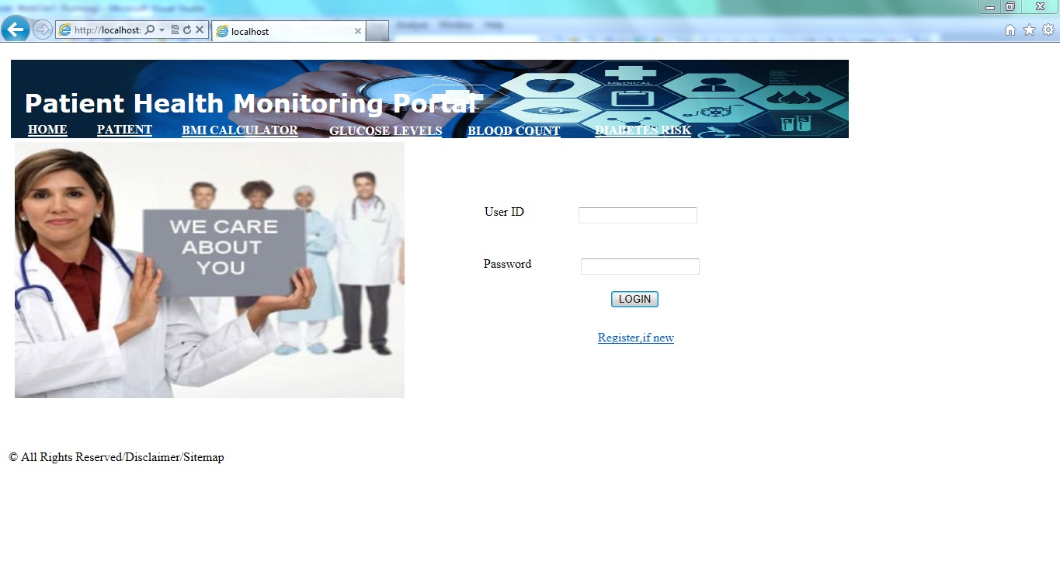

Database Design

Data Model

The following is a schematic view of the database design
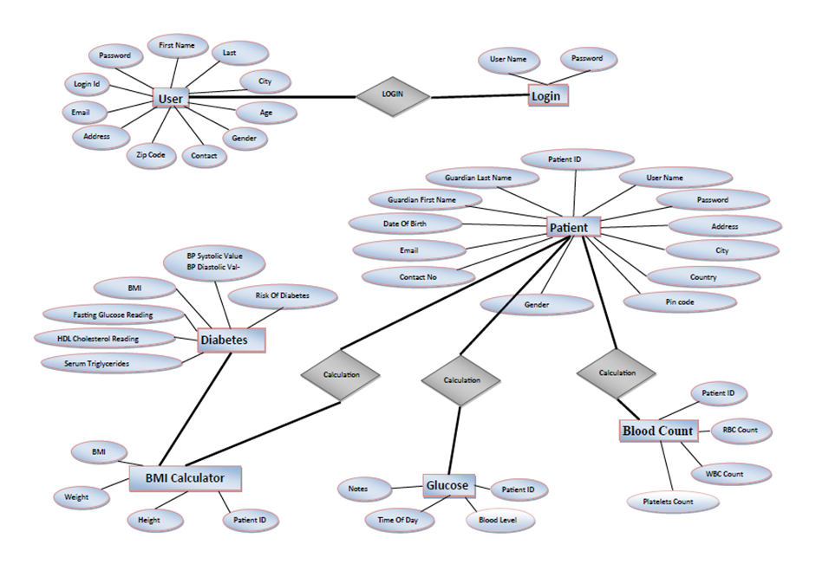

Tables Structure
Admin Registration:
Column Name | Data Type | Length | Nulls
Admin Id | nvarchar | 50 | N
Password | nvarchar | 50 | N
First Name | nvarchar | 50 | N
Last Name | nvarchar | 50 | N
Age | int | 5 | N
Gender | varchar | 10 | N
Contact Number | varchar | 10 | N
Email | nvarchar | 50 | N
Dob | nvarchar | 50 | N
Alt.Contact Number | nvarchar | 50 | Y
Password | nvarchar | 50 | N

Patient Registration:
Column Name | Data Type | Length | Nulls
Patient Id | nvarchar | 10 | N
First Name | nvarchar | 50 | N
Last Name | nvarchar | 50 | N
Date Of Birth | date |  | Y
Email Address | nvarchar | 50 | N
Contact Number | varchar | 10 | N
Address line1 | nvarchar | 250 | N
City | nvarchar | 50 | N
State | nvarchar | 50 | N
Zipcode | varchar | 10 | N
Gender | varchar | 10 | N
Address line 2 | nvarchar | 250 | Y
Alt. Contact Number | nvarchar | 50 | Y

Doctor Registration:
Column Name | Data Type | Length | Nulls
Doctor Id | nvarchar | 10 | N
First Name | nvarchar | 50 | N
Last Name | nvarchar | 50 | N
Date Of Birth | date |  | Y
Email Address | nvarchar | 50 | Y
Contact Number | varchar | 10 | N
Address line1 | nvarchar | 250 | N
City | nvarchar | 50 | N
State | nvarchar | 50 | N
Zipcode | varchar | 10 | N
Gender | varchar | 10 | N
Address line 2 | nvarchar | 250 | Y
Alt. Contact Number | nvarchar | 50 | Y
Degree | varchar | 50 | N
Speciality | Varchar | 50 | N
Work Hours | Varchar | 50 | N

Clerk Registration:
Column Name | Data Type | Length | Nulls
Clerk Id | nvarchar | 10 | N
First Name | nvarchar | 50 | N
Last Name | nvarchar | 50 | N
Date Of Birth | date |  | Y
Email Address | nvarchar | 50 | N
Contact Number | varchar | 10 | N
Address line1 | nvarchar | 250 | N
City | nvarchar | 50 | N
State | nvarchar | 50 | N
Zipcode | varchar | 10 | N
Gender | varchar | 10 | N
Address line 2 | nvarchar | 250 | Y
Alt. Contact Number | nvarchar | 50 | Y

Prescription :
Column Name | Data Type | Length | Nulls
Request Id | nvarchar | 10 | N
Patient Id | nvarchar | 50 | N
Doctor Id | nvarchar | 50 | N
Request date | date |  | N
Medicine Id1 | nvarchar | 50 | N
Quantity 1 | nvarchar | 10 | N
Medicine Id2 | nvarchar | 50 | Y
Quantity 2 | nvarchar | 50 | Y
Medicine Id3 | nvarchar | 50 | Y
Quantity 3 | nvarchar | 50 | Y
Medicine Id4 | varchar | 10 | Y
Quantity 4 | nvarchar | 250 | Y
Medicine Id5 | nvarchar | 50 | Y
Quantity 5 | Nvarcher | 50 | Y
Other Info | Varcher | 100 | Y
Status | Varcher | 50 | N

Medicine Registration:
Column Name | Data Type | Length | Nulls
Medicine Id | nvarchar | 10 | N
Medicine Description | varchar | 200 | N
Cure for | varchar | 100 | N
Manufacturing Company | Varcher | 100 | N
Dosage | nvarchar | 50 | N
Prescribed for | varchar | 50 | N
Amount | nvarchar | 250 | N

Bill Generation :
Column Name | Data Type | Length | Nulls
Bill Id | nvarchar | 10 | N
Patient Id | nvarchar | 50 | N
Doctor Id | nvarchar | 50 | N
Bill date | date |  | N
Medicine Id1 | nvarchar | 50 | N
Quantity 1 | nvarchar | 10 | N
Amount1 | Nvarchar | 50 | N
Medicine Id2 | nvarchar | 50 | Y
Quantity 2 | nvarchar | 50 | Y
Amount 2 | Nvarchar | 50 | Y
Medicine Id3 | nvarchar | 50 | Y
Quantity 3 | nvarchar | 50 | Y
Amount 3 | Nvarchar | 50 | Y
Medicine Id4 | varchar | 10 | Y
Quantity 4 | nvarchar | 250 | Y
Amount 4 | Navarchar | 20 | Y
Medicine Id5 | nvarchar | 50 | Y
Quantity 5 | Nvarcher | 50 | Y
Amoount5 | nvarcher | 20 | Y
Total Amount | nvarchar | 50 | N

Change Log
Please note that this table needs to be maintained even if a Configuration Management tool is used.
Version Number | Changes made
V1.0 | <First version>
V1.1 | <If the change details are not explicitly documented in the table below, reference should be provided here>
V1.1 | Page no | Changed by | Effective date | Changes effected
V1.2 | <If the change details are not explicitly documented in the table below, reference should be provided here>
V1.2 | Page no | Changed by | Effective date | Changes effected

